Real Capstone
Epilogue 3 — The Recognition
Michael Harris
March 2026
What the App Was Built to Do
The Clear Seeing Guide was built for a specific problem. A person is caught in a situation that feels stuck, complex, or charged. They've been thinking about it. They've told the story many times. The thinking hasn't helped — in fact, the thinking is part of what's keeping them stuck.
What the app does is interrupt that. Not by providing answers. Not by reframing the story. By bringing the person into contact with what is actually happening beneath the story — the physical sensation, the charge, the thing being avoided.
When that contact happens, something shifts. The situation that looked complex a moment ago looks different. Not because new information arrived. Because the aperture widened. And from the wider view, what was previously invisible becomes obvious.
That's the mechanism. Contracted aperture makes a simple situation look unsolvable. Wider aperture reveals what was already there.
I built this tool for personal emotional work. That was the domain I understood. That was the problem I had lived and studied and written about. I wasn't thinking about other applications. I was trying to build one thing that worked well.

What Happened During the Build
Weeks into the build, the app wouldn't deploy. The technical explanation kept getting more complex — Gunicorn, Unix sockets, container runtimes, port binding, WSGI interfaces. A week passed. The problem looked like deep infrastructure. It looked like it might require platform-level intervention.
Then I stopped trying to solve it and did something different. I asked for the system to be explained in plain terms. Not the technical terms. The actual flow. What moves where. What each piece does. Strip everything else away.
The result was a simple diagram. Customer enters through a door. Receptionist routes them. Security checks credentials. Waiter takes the order. Kitchen prepares the response. Six boxes. A circle.
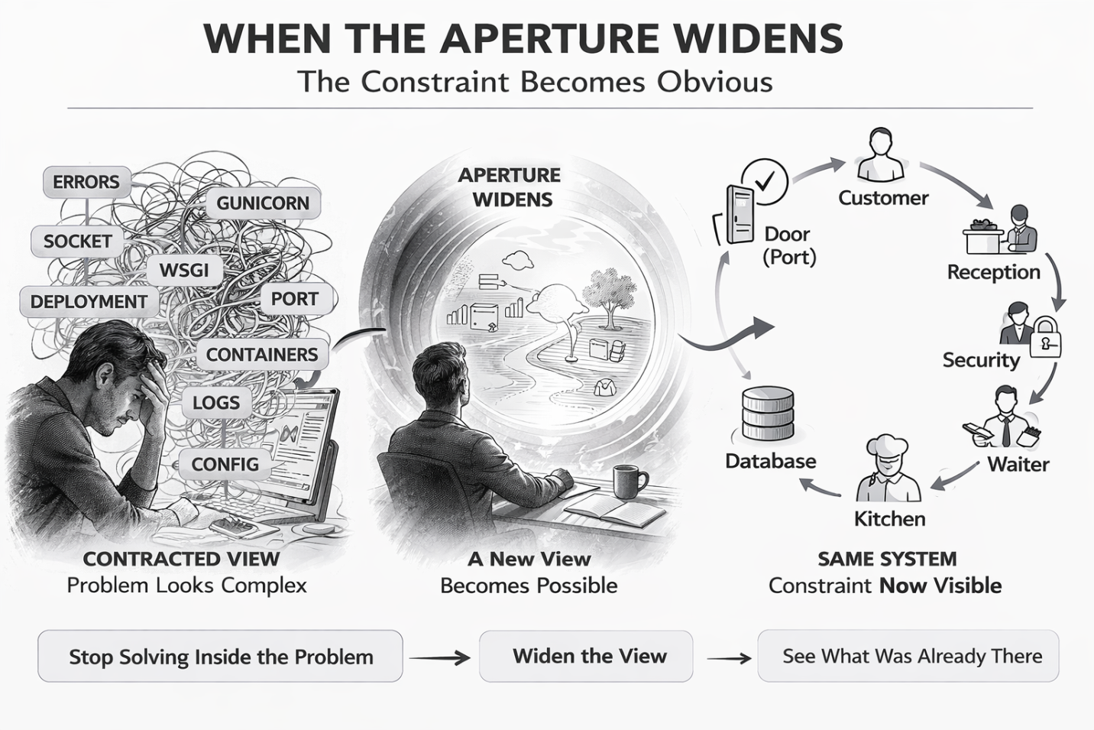
I looked at it and the answer was just there. The door wasn't opening. Everything else in the system was fine. The constraint was obvious. The fix was two words.
I hadn't thought my way to it. I hadn't been particularly brilliant. The aperture widened and the answer was already there, waiting.
That's the app. I just experienced my own tool on a completely different problem.
Not a personal situation. Not an emotional charge. A technical deployment problem. Same mechanism. Contracted view made it look like deep infrastructure. Wider view revealed a trivial constraint. Solution obvious once visible.

The Recognition
This is not a sophisticated insight. It's a simple observation. The mechanism I built the app around is not specific to personal emotional work.
Aperture tightening is what happens when any system — a person, a founder, an engineer, a salesperson — gets contracted around a problem. The contracted view isn't lying. Everything it shows is real. It's just incomplete. And from inside the contraction, the incompleteness is invisible. The problem looks like the whole picture.
What the app does — create the conditions for the aperture to widen — works on any contracted view. The domain changes. The mechanism doesn't.
I had already been thinking about this in the context of sales. A salesperson in a difficult conversation often gets contracted around the objection — the specific words, the specific resistance, the specific thing the customer said. They try to solve it at that level. More features. Better pricing. Stronger argument. The contraction drives the strategy.
But the customer's objection is rarely the real constraint. The real constraint is usually something upstream — a fear, an assumption, a situation they haven't named. When the aperture opens on that, the objection often dissolves on its own. Not because it was argued away. Because it was never the actual problem.
Same mechanism. Different domain.
I don't know yet where this leads. I'm not going to pretend otherwise. But you don't ignore a recognition like this just because the path forward isn't clear yet.

What the Charge Actually Is
After working through the deployment problem — the restaurant model, the constraint, the two-word fix — I noticed something more precise about what had been happening.
The charge wasn't just confusion. It was a specific structure.
The nervous system generates a prediction — how things should work, what a technical explanation should feel like when it's correct, what the system should be doing. When reality doesn't match that prediction, a gap opens. That gap produces a signal. That signal is the charge.
Every charged situation has this structure. Not just technical problems. Every one. The prediction and the reality are out of alignment, and the gap between them is what produces the friction, the bracing, the contracted view.
Most responses to that signal are attempts to close the gap without feeling it. Fix the reality to match the prediction. Reframe the prediction to match the reality — but through story, not contact. Avoid looking at either. Or simply flee.
What I did with the deployment problem was different. I didn't try to fix it faster. I didn't accept the expert explanation to relieve the discomfort. I held the gap — the not-knowing, the mismatch, the discomfort of both being true simultaneously — until the wider view appeared on its own.
The gap dissolved not because I changed the reality or revised my prediction. It dissolved because the wider view showed a model where both finally made sense. The abstraction and the reality came back into alignment. The charge released. The answer was obvious.
That is exactly what the app does with users.
The app holds the person in the gap between their prediction — how the situation should be, how people should behave, what should happen — and the reality of what is actually here. Not fixing it. Not reframing it. Not fleeing. Holding both forces simultaneously until the wider view becomes available.
This is why the mechanism works. The charge isn't a problem to be solved. It's a signal that the prediction model and reality have lost contact. The app creates conditions for that contact to be restored — not through insight or reframing, but through staying with the gap long enough that it shows what it's actually protecting.
The technical situation I experienced was a lighter version of the same structure. No deep personal horror underneath. Just a mismatch between what an expert was telling me and what my experience of the system was telling me. Same shape. Different depth. Different charge intensity.
But the move was identical. Stop pushing. Feel the discomfort. Sit with both forces. Wait for clear seeing.
The mechanism works at every scale. From the terror of a life situation that feels impossible to the friction of a technical explanation that doesn't quite sit right. The charge is always the same structure — a gap between prediction and reality. And the aperture always widens the same way — by staying with the gap rather than immediately trying to close it.

What I Know
I know that I built a tool for one domain and experienced its mechanism in another. That happened without trying. It happened because the mechanism is real — not because I designed it to generalize.
I know that the contracted view is not a personal or emotional phenomenon. It's a perceptual one. It happens to people in therapy and it happens to founders staring at deployment logs. The content is different. The structure is identical.
I know that the conditions required for the aperture to widen are learnable and reproducible. The app does it through conversation. The restaurant diagram did it through a simple visual. What they share is not the method — it's the intention: stop solving at the level of the contraction and widen the view until the actual gap becomes visible.
I know that this is worth paying attention to.
Where it goes from here — whether this becomes a framework, a different product, a way of working with salespeople or leaders or teams — I genuinely don't know yet. Claiming otherwise would be the same mistake the contracted view always makes: filling in what isn't visible yet with a story that feels certain.
The wider view doesn't come with a map. It comes with clarity about what's actually here. That's enough to start from.

That's the recognition.
Not a conclusion. A beginning.

